Effective Advertisement Design
Objective: Students will create a newspaper, magazine, radio, television, and public service announcement advertisements for a target audience.
Students will use multimedia tools to record voice and manipulate images or sound.
Students will brainstorm and incorporate new ideas for multimedia advertisements.
Students will apply principles of design in advertisements.
Brainstorm how to achieve effective advertisement design for each type. Some ideas to consider but be creative:
- Product or service to advertise
- Purpose of advertisement
- Target audience (demographic characteristics) (how to gain attention and influence purchase)
- Medium features (newspaper, magazines, radio, television, computer)
- Message to be communicated (fact/opinion, actual or implied)
- Advertising techniques used and why (research example)
  - repetition – build identity awareness and customer memory be repeating company name in visual and audio
  - claims – promote specific features
  - association – associating a product with famous person, jingle, or powerful emotion
  - bandwagon – convince others are using it and they should join the crowd
  - promotions – offer coupons, sweepstakes, games with prizes, or gifts to create excitement
- Multimedia options
- Visual appearance – apply principles of design (balance, rhythm, proximity, alignment, repetition, contrast, and space)

What are the problems with this magazine ad?
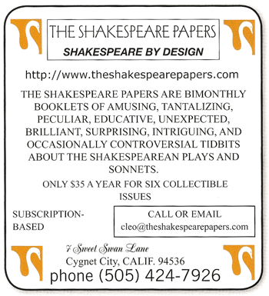
Name 6 problems so you can find the solutions.
Clues:
- Is there one main focal point? Why not, and how could you create one?
- WHY IS SO MUCH OF THE TEXT IN ALL CAPS?
- Do you need the heavy border and the inner boxes?
- How many different typefaces are in this ad?
- How many different alignments?
- Are the logical elements grouped together into close proximity?
- What could you use as repetitive elements?

Knowing where to begin can sometimes seem overwhelming. First get rid of everything superfluous so you know what you're working with:
- What should be the focal point?
- What is the purpose of this advertisement? That will help you determine the hierarchy of the rest of the information.
- Which items should be grouped together into closer proximity?

http://www.nhsdesigns.com/principles/review/page07.php

